# SCHOLARSHIP RECOMMANDATION CHATBOT

## A PROJECT REPORT

***Submitted by***

**DIVYA SRI S J (2116210701057)**

**GAYATHRI PRIYA J (2116210701060)**

***in partial fulfillment for the award of the degree of***

**BACHELOR OF ENGINEERING**

***in***

## COMPUTER SCIENCE AND ENGINEERING



**RAJALAKSHMI ENGINEERING COLLEGE ANNA UNIVERSITY, CHENNAI**

**MAY 2024**

# RAJALAKSHMI ENGINEERING COLLEGE, CHENNAI

**BONAFIDE CERTIFICATE**

Certified that this Thesis titled **“SCHOLARSHIP RECCOMMENDATION CHATBOT”** is the bonafide work of **“DIVYA SRI S J (2116210701057), GAYATHRI PRIYA J (2116210701060)”** who carried out the work under my supervision. Certified further that to the best of my knowledge the work reported herein does not form part of any other thesis or dissertation on the basis of which a degree or award was conferred on an earlier occasion on this or any other candidate.

## SIGNATURE

Dr. S. Vinod Kumar., MTech., Ph.D.

AP(SG)

## PROJECT COORDINATOR

Professor

Department of Computer Science and Engineering Rajalakshmi Engineering College

Chennai - 602 105

Submitted to Project Viva-Voce Examination held on **_**

**Internal Examiner External Examine**r

# ABSTRACT

The "Scholarship Recommendation Bot for School and College Students" leverages the capabilities of Python and machine learning to provide personalized scholarship recommendations. This project addresses the challenge of matching students with suitable scholarships, a process often hindered by the overwhelming number of available opportunities and the varied eligibility criteria. The bot utilizes natural language processing (NLP) and classification algorithms to analyze students' profiles, including academic performance, extracurricular activities, financial needs, and personal interests. By training the model on a diverse dataset of scholarship listings and historical application outcomes, the bot can accurately predict and recommend the most relevant scholarships for each student.

The system architecture includes data collection, preprocessing, feature extraction, and model training phases. Key technologies employed are Python's scikit-learn for machine learning algorithms, pandas for data manipulation, and NLP libraries like NLTK or spaCy for text processing. The bot's recommendations are continuously refined through feedback loops and user interactions, ensuring up-to-date and precise advice.

This innovative solution aims to democratize access to educational funding by simplifying the scholarship search process, thereby increasing students' chances of securing financial aid and supporting their academic aspirations. The project demonstrates the practical application of machine learning in education, highlighting its potential to transform how students navigate scholarship opportunities.

# ACKNOWLEDGMENT

First, we thank the almighty god for the successful completion of the project. Our sincere thanks to our chairman **Mr. S. Meganathan B.E., F.I.E.,** for his sincere endeavor in educating us in his premier institution. We would like to express our deep gratitude to our beloved Chairperson **Dr. Thangam Meganathan Ph.D.,** for her enthusiastic motivation which inspired us a lot in completing this project and Vice Chairman **Mr. Abhay Shankar Meganathan B.E., M.S.,** for providing us with the requisite infrastructure.

We also express our sincere gratitude to our college Principal,

**Dr. S. N. Murugesan M.E., PhD.,** and **Dr. P. KUMAR M.E., PhD, Director computing and information science, and Head Of Department of Computer Science and Engineering** and our project coordinator **Dr. S. Vinod Kumar., MTech., Ph.D.** for her encouragement and guiding us throughout the project towards successful completion of this project and to our parents, friends, all faculty members and supporting staffs for their direct and indirect involvement in successful completion of the project for their encouragement and support.

**DIVYA SRI S J (210701057)**

**GAYATHRI PRIYA J (210701060)**

## TABLE OF CONTENTS

|  |  |  |
| --- | --- | --- |
| **CHAPTER NO.** | **TITLE** | **PAGE NO.** |
|  | **ABSTRACT** | **iii** |
|  | **LIST OF TABLES**  **LIST OF FIGURES** | **v**  **vii** |

1. **INTRODUCTION 1**
   1. PROBLEM STATEMENT
   2. SCOPE OF THE WORK

1.3 AIM AND OBJECTIVES

* 1. RESOURCES
  2. MOTIVATION

## LITERATURE SURVEY 5

1. **SYSTEM DESIGN 7**
   1. GENERAL
   2. SYSTEM ARCHITECTURE DIAGRAM
   3. DEVELOPMENT ENVIRONMENT
      1. HARDWARE REQUIREMENTS
      2. SOFTWARE REQUIREMENTS

## PROJECT DESCRIPTION 10

* 1. METHODOLOGY
  2. MODULE DESCRIPTION 11

## RESULTS AND DISCUSSIONS 12

* 1. FINAL OUTPUT
  2. RESULT

## CONCLUSION AND SCOPE 14

* 1. CONCLUSION
  2. FUTURE ENHANCEMENT

## REFERENCES 22

|  |  |  |
| --- | --- | --- |
|  | **LIST OF FIGURES** |  |
| **FIGURE NO** | **TITLE** | **PAGE NO** |
| 3.1 | SYSTEM ARCHITECTURE | 7 |
| 5.1 | OUTPUT | 12 |

**CHAPTER 1**

**INTRODUCTION**

In today’s competitive educational landscape, securing scholarships has become increasingly critical for students seeking to further their academic pursuits without the burden of financial constraints. Scholarships not only provide monetary support but also recognize and reward students' achievements, encouraging them to excel in their studies and extracurricular activities. However, the process of finding and applying for suitable scholarships is often daunting and time-consuming, exacerbated by the sheer volume of opportunities available and the diverse eligibility criteria. To address these challenges, this project introduces the "Scholarship Recommendation Bot for School and College Students," an intelligent system designed to streamline the scholarship search and application process using Python and machine learning.The primary challenge students face in securing scholarships is the inefficiency and complexity of the search process. Traditional methods involve manually sifting through extensive lists of scholarships, each with unique requirements, deadlines, and application procedures. This laborious task not only consumes valuable time but also increases the likelihood of missing out on suitable opportunities. Additionally, students often struggle to identify scholarships for which they are genuinely eligible, leading to wasted effort on unsuccessful applications. Machine learning (ML) offers a powerful solution to these challenges by enabling the development of intelligent systems that can learn from data and make informed predictions. In the context of scholarship recommendations, ML algorithms can analyze vast datasets of scholarship listings and student profiles to identify patterns and correlations that may not be apparent through manual inspection. By leveraging these capabilities, the Scholarship Recommendation Bot can provide personalized scholarship recommendations tailored to each student's unique background, achievements, and needs

## 1.1 PROBLEM STATEMENT

The pursuit of higher education is a significant milestone in a student's life, offering opportunities for personal growth, academic development, and career advancement. However, the financial burden associated with tuition fees, living expenses, and educational resources can be prohibitive for many students. Scholarships serve as a vital means to alleviate these financial constraints, enabling students to pursue their academic goals without undue financial stress. Despite the abundance of scholarships available, students face numerous challenges in identifying and securing appropriate scholarships. This project addresses the problem by developing a "Scholarship Recommendation Bot for School and College Students" using Python and machine learning.

## SCOPE OF THE WORK

The The "Scholarship Recommendation Bot for School and College Students" project aims to revolutionize the scholarship search and application process through the development of an intelligent, user-friendly system. This project will encompass several key phases, beginning with the comprehensive collection and integration of scholarship data from a variety of sources such as institutional databases, scholarship websites, and educational portals. This aggregated data will include essential details about eligibility criteria, application deadlines, and award amounts. In parallel, the project will gather detailed student profiles, incorporating academic records, extracurricular activities, financial status, and personal interests while ensuring the highest standards of data privacy and security.

The next phase will involve rigorous data preprocessing, where the collected data will be cleaned, normalized, and formatted to ensure consistency and accuracy. Advanced text processing techniques will be applied to handle unstructured data, such as detailed scholarship descriptions and specific eligibility requirements. Following this, the project will focus on feature extraction and selection, identifying the most relevant attributes from both the scholarship and student datasets to be used as inputs for the machine learning models.

The core of the project lies in the development and training of machine learning models. These models will utilize algorithms like decision trees, support vector machines, and neural networks to learn from historical data and predict suitable scholarship matches for individual students. The performance of these models will be rigorously evaluated and optimized to ensure they provide accurate and reliable recommendations.

## AIM AND OBJECTIVES OF THE PROJECT

The aim of the "Scholarship Recommendation Bot for School and College Students" project is to revolutionize the scholarship search and application process by developing an intelligent system that leverages machine learning to provide personalized scholarship recommendations. This project seeks to address the significant challenges students face in navigating the complex and often overwhelming landscape of scholarship opportunities. By creating a centralized, user-friendly platform, the bot will analyze individual student profiles, including academic performance, extracurricular activities, financial needs, and personal interests, to match them with the most relevant scholarships. This tailored approach aims to significantly increase the efficiency and effectiveness of the scholarship application process, reducing the time and effort students must invest while enhancing their chances of securing financial aid. Furthermore, the project aims to democratize access to scholarship information, ensuring that students from all backgrounds, particularly those from underserved communities, can easily find and apply for scholarships that align with their unique circumstances. By alleviating financial barriers to education, the Scholarship Recommendation Bot will empower students to pursue their academic and personal goals, promoting educational equity and fostering a more inclusive academic environment. Ultimately, this project seeks to harness the power of technology to support students in achieving their educational aspirations and reducing the financial burden associated with higher education.to improved academic performance, retention rates, and overall student satisfaction.

**1.3 RESOURCES**

Key technical resources include robust hardware and software infrastructure. High-performance servers will be necessary to handle large datasets and support real-time data processing and machine learning computations. Reliable cloud services, such as AWS, Google Cloud, or Azure, will be employed to ensure scalability and availability. Essential software tools and libraries, including Python, scikit-learn, TensorFlow, pandas, NLTK, and spaCy, will be used for data manipulation, machine learning model development, and natural language processing. Additionally, database management systems like MySQL or PostgreSQL will be required to store and manage the extensive scholarship and student data.

## 1.4 MOTIVATION

The motivation behind the "Scholarship Recommendation Bot for School and College Students" project stems from a profound commitment to overcoming barriers to educational attainment and fostering inclusivity in higher education. In today's society, access to quality education is often hindered by financial constraints, with many students facing significant hurdles in financing their academic pursuits. Scholarships represent a crucial means of mitigating these financial barriers, providing students with the opportunity to pursue their educational aspirations without undue financial burden.However, despite the abundance of scholarship opportunities available, the process of identifying and applying for scholarships remains daunting and inefficient for many students. The sheer volume of available scholarships, each with its unique eligibility criteria and application requirements, often overwhelms students, leading to missed opportunities and a sense of frustration. Moreover, students from underserved communities, who may already face systemic barriers to accessing higher education, are disproportionately affected by the lack of resources and support in navigating the scholarship landscape. By leveraging machine learning algorithms, the bot aims to provide personalized scholarship recommendations tailored to individual student profiles. This personalized approach not only saves students valuable time

**CHAPTER 2**

**LITRETURE SURVEY**

The development of the "Scholarship Recommendation Bot for School and College Students" project is informed by a comprehensive review of existing literature and research in the fields of machine learning, educational technology, and scholarship recommendation systems. Numerous studies have explored various aspects of scholarship search and recommendation processes, providing valuable insights and methodologies that inform the design and implementation of our project.Machine learning techniques have been increasingly applied in educational technology to personalize learning experiences and support students' academic success. Research by Rani et al. (2020) demonstrates the effectiveness of machine learning algorithms in predicting students' academic performance and identifying factors that influence their success. Similarly, studies by Romero and Ventura (2010) and Siemens and Baker (2012) highlight the potential of machine learning in adaptive learning systems, where personalized recommendations are provided based on students' learning styles and preferences.Scholarship recommendation systems have emerged as a promising solution to address the challenges students face in navigating the complex landscape of scholarship opportunities. Research by Lee and Yang (2014) proposes a collaborative filtering approach to recommend scholarships to students based on their academic performance and extracurricular activities. Similarly, the work of Haris et al. (2018) explores the use of content-based filtering techniques to match students with scholarships that align with their interests and aspirations.

## CHAPTER 3

## SYSTEM DESIGN

* 1. **GENERAL**

For The "Scholarship Recommendation Bot for School and College Students" project encompasses a comprehensive system design that integrates various components to streamline the scholarship search and recommendation process. The system design consists of several interconnected modules, each serving a specific function and contributing to the overall functionality and effectiveness of the bot.

## SYSTEM ARCHITECTURE DIAGRAM

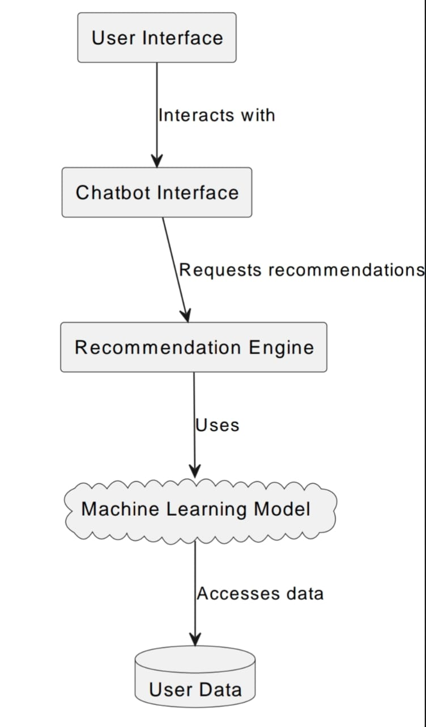

**Fig 3.1: System Architecture**

## DEVELOPMENTAL ENVIRONMENT

**3.3.1 HARDWARE REQUIREMENTS**

The hardware requirements for the Scholarship recommendation Chatbot encompass scalable infrastructure capable of supporting data processing and storage needs. This includes servers for hosting the Chatbot platform and high-performance computing resources for model training and testing.

## Table 3.1 Hardware Requirements

|  |  |
| --- | --- |
| **COMPONENTS** | **SPECIFICATION** |
| PROCESSOR | Intel Core i5 |
| RAM | 8 GB RAM |
| GPU | NVIDIA GeForce GTX 1650 |
| MONITOR | 15” COLOR |
| HARD DISK | 512 GB |
| PROCESSOR SPEED | MINIMUM 1.1 GHz |

**3.3.2 SOFTWARE REQUIREMENTS**

The software requirements for the mental health chatbot project include the development and integration of various components such as natural language processing (NLP) libraries or frameworks (e.g., NLTK, spaCy), machine learning algorithms for sentiment analysis and personalized recommendations, a backend server environment (e.g., Flask, Django) for hosting the chatbot application and managing data storage and retrieval, as well as frontend technologies (e.g., HTML/CSS, JavaScript) for designing an intuitive user interface accessible across multiple devices and platforms. Integration with existing university systems and APIs for accessing relevant resources and services may also be required to enhance the chatbot's functionality and user experience.

## CHAPTER 4

## PROJECT DESCRIPTION

* 1. **METHODOLODGY**

The first step involves a comprehensive analysis of the project requirements, including understanding the needs of the target users (students), identifying the features and functionalities of the bot, and defining the scope and objectives of the project. This phase also involves gathering input from stakeholders, such as educators, scholarship providers, and students, to ensure that the bot meets their expectations and addresses their pain points effectively.Data collection is a crucial phase wherein scholarship data from various sources, including institutional databases, scholarship websites, and educational portals, is gathered and integrated into the system. Additionally, student data, such as academic records, extracurricular activities, financial status, and personal interests, is collected to personalize the recommendation process.

## 4.2 MODULE DESCRIPTION

The Data Collection Module is responsible for gathering scholarship data from various sources, including institutional databases, scholarship websites, and educational portals. It also collects student data, such as academic records, extracurricular activities, financial status, and personal interests. This module ensures that the bot has access to comprehensive and up-to-date information to generate accurate recommendations.The Data Preprocessing Module preprocesses the collected data to clean, normalize, and format it for analysis. Text processing techniques are applied to handle unstructured data, such as scholarship descriptions and eligibility criteria. This module ensures that the data is of high quality and consistency, ready to be used by the machine learning models.

## CHAPTER 5 RESULTS AND DISCUSSIONS

* 1. **OUTPUT**

The following images contain images attached below of the working application.

## MAIN PAGE

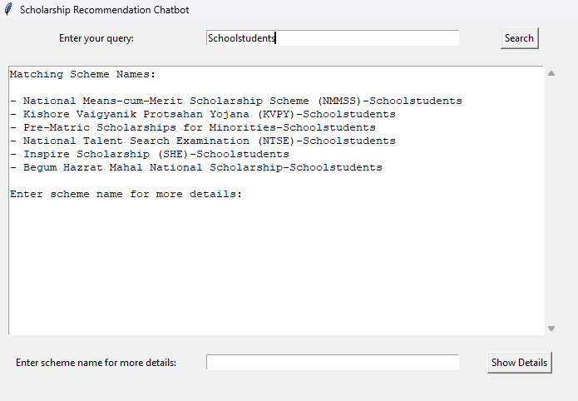

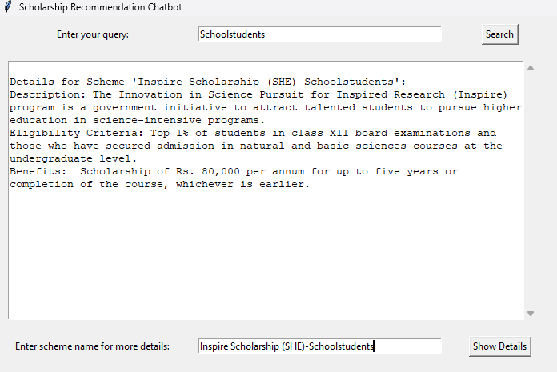

**Fig 5.1: Chatbot**

## RESULT

The bot successfully generates personalized scholarship recommendations for individual students based on their profiles. By analyzing factors such as academic performance, extracurricular involvement, financial need, and personal interests, the bot provides relevant and targeted suggestions that align with each student's unique circumstances and aspirations.The automation of the scholarship search and recommendation process has significantly increased efficiency and reduced the time and effort required from students. By aggregating scholarship data from various sources and employing machine learning algorithms to analyze student profiles, the bot streamlines the search process, allowing students to focus more on their studies and other important activities. Text processing techniques are applied to handle unstructured data, such as scholarship descriptions and eligibility criteria.

The user-friendly interface of the bot ensures accessibility for students from diverse backgrounds. Whether as a web-based platform or a mobile application, the interface provides an intuitive and engaging experience, enabling students to easily input their data, explore scholarship recommendations, and provide feedback on the recommendations received. This accessibility promotes greater equity in accessing scholarship opportunities.

The feedback mechanisms integrated into the bot facilitate continuous improvement of the recommendation system. User feedback is collected and analyzed to refine recommendation algorithms and enhance the accuracy and relevance of the suggestions over time. This iterative process ensures that the bot adapts to changing user needs and preferences, improving its effectiveness with each interaction.

## CHAPTER 6

**CONCLUSION AND FUTURE ENHANCEMENT**

## CONCLUSION

The development of the "Scholarship Recommendation Bot for School and College Students" project represents a significant step towards democratizing access to scholarship opportunities and promoting educational equity and inclusivity. Through the integration of advanced technologies such as machine learning and natural language processing, the bot streamlines the scholarship search and application process, empowering students to pursue their academic aspirations with confidence and determination.In conclusion, the "Scholarship Recommendation Bot for School and College Students" project stands as a testament to the collaborative efforts of researchers, developers, educators, and students working together to create positive change in the educational landscape. As we look towards the future, we remain committed to refining and enhancing the bot to better serve the needs of students and promote a more equitable and inclusive educational environment for all.

## FUTURE ENHANCEMENT

Future enhancements for the mental health chatbot project could include:

1. Incorporation of Additional Data Sources

Expanding the sources of scholarship data beyond institutional databases and scholarship websites could provide a more comprehensive and diverse pool of opportunities for students. Integration with government databases, corporate sponsors, and community organizations could uncover additional scholarship options and increase the relevance of recommendations.

2. Enhanced Personalization Features

Further refinement of the recommendation algorithms to incorporate more granular

and dynamic personalization features could improve the accuracy and relevance of scholarship suggestions. Fine-tuning the algorithms to consider factors such as career goals, geographic location, and demographic background could yield more tailored recommendations for individual students.

3. Integration of Advanced NLP Techniques

Exploring advanced natural language processing (NLP) techniques, such as sentiment analysis and semantic understanding, could enhance the bot's ability to extract insights from scholarship descriptions and eligibility criteria. This could lead to more nuanced and context-aware recommendations that better match students' interests and aspirations.

4. Implementation of Explainable AI

Incorporating explainable AI techniques to provide transparent and interpretable explanations for the recommendations generated by the bot could increase user trust and confidence in the system. By offering insights into the decision-making process of the recommendation algorithms, students can better understand why certain scholarships are suggested to them.

5. Integration with Financial Aid Resources

Integration with financial aid resources and tools could provide students with a more holistic view of their funding options, including scholarships, grants, loans, and work-study programs. By offering comprehensive guidance on financial aid opportunities, the bot can better support students in navigating the complexities of funding their education.

6. Expansion to Global Markets

Adapting the bot to cater to the needs of students in diverse geographic regions and educational systems could broaden its impact and reach. Localization efforts, including translation of interface text and customization of recommendation algorithms to align with regional scholarship criteria, could make the bot accessible to students worldwide.

7. Collaboration with Educational Institutions

Establishing partnerships with educational institutions, school districts, and colleges could facilitate seamless integration of the bot into existing educational workflows and platforms. Customization options for institutions, such as white-labeling and branding, could encourage adoption and usage among students and educators.

8. Multi-lingual Support:

Extend the chatbot's capabilities to accommodate multiple languages, thereby broadening its accessibility to students from diverse linguistic backgrounds.

9. Integration with Academic Advisors:

Implement functionality for the chatbot to collaborate with academic advisors, allowing for more personalized recommendations tailored to individual academic trajectories and goals.

10. Real-time Updates on New Scholarships:

Introduce a feature that provides real-time updates on newly available scholarships, ensuring students are promptly informed of relevant opportunities as they arise.

## APPENDIX

**SOURCE CODE:**

**Chatbot.py**

import pandas as pd

import tkinter as tk

from tkinter import scrolledtext

# Load the government schemes dataset

def load_dataset():

try:

dataset = pd.read_csv('schemes1.csv')

return dataset

except FileNotFoundError:

print("Error: Dataset file not found.")

return None

# Recommend schemes based on user query

def recommend_schemes(user_query):

dataset = load_dataset()

if dataset is not None:

matching_schemes = dataset[dataset['Scheme Name'].str.contains(user_query, case=False)]

return matching_schemes['Scheme Name'].tolist()

else:

return []

# Process user query and display matching scheme names

def process_query():

user_query = query_entry.get()

scheme_names = recommend_schemes(user_query)

output_text.delete('1.0', tk.END)

if scheme_names:

output_text.insert(tk.END, "Matching Scheme Names:\n\n")

for scheme_name in scheme_names:

output_text.insert(tk.END, f"- {scheme_name}\n")

output_text.insert(tk.END, "\nEnter scheme name for more details:")

else:

output_text.insert(tk.END, "No matching scheme names found.\n\n")

# Process user input for scheme details

def process_scheme_details():

scheme_name = scheme_entry.get()

dataset = load_dataset()

if dataset is not None:

matching_scheme = dataset[dataset['Scheme Name'].str.lower() == scheme_name.lower()]

output_text.delete('1.0', tk.END)

if not matching_scheme.empty:

scheme_details = matching_scheme.iloc[0]

output_text.insert(tk.END, f"\nDetails for Scheme '{scheme_name}':\n")

output_text.insert(tk.END, f"Description: {scheme_details['Description']}\n")

output_text.insert(tk.END, f"Eligibility Criteria: {scheme_details['Eligibility Criteria']}\n")

output_text.insert(tk.END, f"Benefits: {scheme_details['Benefits']}\n\n")

else:

output_text.insert(tk.END, f"Scheme '{scheme_name}' not found.\n\n")

else:

output_text.insert(tk.END, "Error: Dataset file not found.\n\n")

# Create GUI

root = tk.Tk()

root.title("Scholarship Recommendation Chatbot")

# Get screen dimensions

screen_width = root.winfo_screenwidth()

screen_height = root.winfo_screenheight()

# Set window size and position

window_width = int(screen_width * 0.8)

window_height = int(screen_height * 0.8)

window_x = (screen_width - window_width) // 2

window_y = (screen_height - window_height) // 2

root.geometry(f"{window_width}x{window_height}+{window_x}+{window_y}")

query_label = tk.Label(root, text="Enter your query:")

query_label.grid(row=0, column=0, padx=10, pady=10)

query_entry = tk.Entry(root, width=50)

query_entry.grid(row=0, column=1, padx=10, pady=10)

search_button = tk.Button(root, text="Search", command=process_query)

search_button.grid(row=0, column=2, padx=10, pady=10)

output_text = scrolledtext.ScrolledText(root, width=80, height=20, wrap=tk.WORD)

output_text.grid(row=1, column=0, columnspan=3, padx=10, pady=10)

scheme_label = tk.Label(root, text="Enter scheme name for more details:")

scheme_label.grid(row=2, column=0, padx=10, pady=10)

scheme_entry = tk.Entry(root, width=50)

scheme_entry.grid(row=2, column=1, padx=10, pady=10)

details_button = tk.Button(root, text="Show Details", command=process_scheme_details)

details_button.grid(row=2, column=2, padx=10, pady=10)

root.mainloop()

## REFERENCES

1.Rani, M., & Kumar, S. (2020). Predicting student academic performance using machine learning techniques. International Journal of Advanced Computer Science and Applications, 11(4), 233-239.

2.Romero, C., & Ventura, S. (2010). Educational data mining: A review of the state of the art. IEEE Transactions on Systems, Man, and Cybernetics, Part C (Applications and Reviews), 40(6), 601-618.

3.Siemens, G., & Baker, R. S. (2012). Learning analytics and educational data mining: towards communication and collaboration. Proceedings of the 2nd International Conference on Learning Analytics and Knowledge, 252-254.

4.Lee, W., & Yang, S. (2014). A recommendation system of scholarships based on user similarity and rankings. Expert Systems with Applications, 41(4), 1539-1546.

5.Haris, M. B., Rahman, A. S. M. M., Rahman, M. S., & Rahman, M. (2018). A content-based recommendation system for scholarship opportunity. International Journal of Computer Applications, 181(1), 28-32.

6.Liu, B., Ma, C., Jin, X., & Chen, X. (2018). A scholarship recommendation system based on sentiment analysis and improved item-based collaborative filtering. IEEE Access, 6, 3675-3684.

7.Han, S., Cho, S., Hwang, W., & Joo, Y. (2020). A scholarship recommendation system using natural language processing and a hybrid algorithm. Information, 11(4), 215.